Create a report in Microsoft Word, and answer the following questions:

* Given the provided data, what are three conclusions that we can draw about crowdfunding campaigns?

1. Given the data provided, in Crowdfunding projects are more likely to be successful than to fail or get cancelled. What’s interesting is that if we look into the outcomes of completed projects as separate categories we see a stark difference (if we filter by successful and failed outcomes only). The implication is that in music , theatre , film and video, have the highest success rates and food , games and journalism have the lowest success rates. One more thing to point out is that technology projects get canceled about a third of the time, when we look at the projects that reached completion only seventy percent are successful. If this information were presented they would probably think twice about supporting the goals of certain categories.

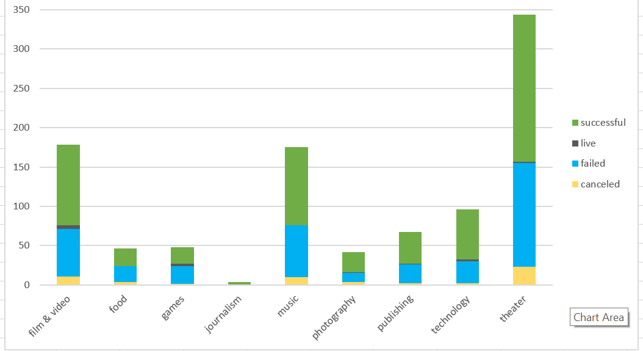

1. Now, if we look into the individual forty-one subcategories we can see which subcategories are the most successful. We will talk about rates though they are not very statistically significant since the sample size is so small. When we look at the subcategory projects that were completed meaning that they were either successful or Failed, we have subcategories with a hundred percent success rate: World Music and Audio We also donot have project subcategories that were a hundred percent failed: However, it is critical to reemphasize the numbers may not be statistically significant given that the sample is even smaller to derive solid conclusion. A safe conclusion to make, is that plays are very popular.

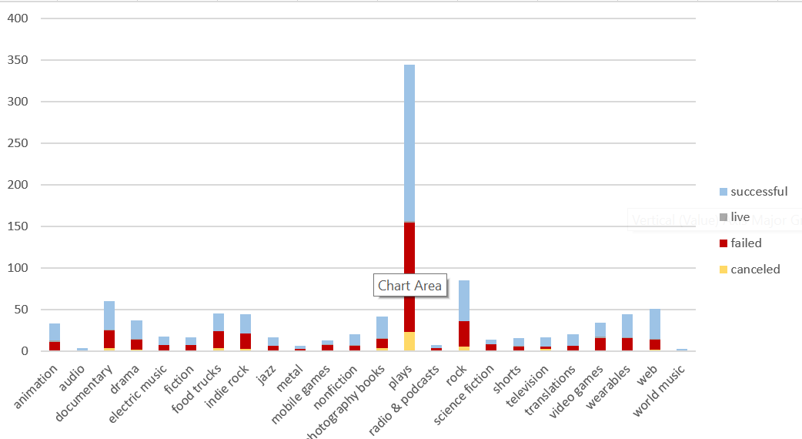

1. Finally, past mid-May we have an accelerated decrease of success and the gap between successful and failed narrows down until the month of December when the lines intersect and the failed count surpasses successful for the first time. What this suggests is that we need to look at the information such as the percent funded for the highest and lowest success count and see if we can see significant correlations. Even when we filter the last months of the year by category no industry shows a trend of “success” in the month December.

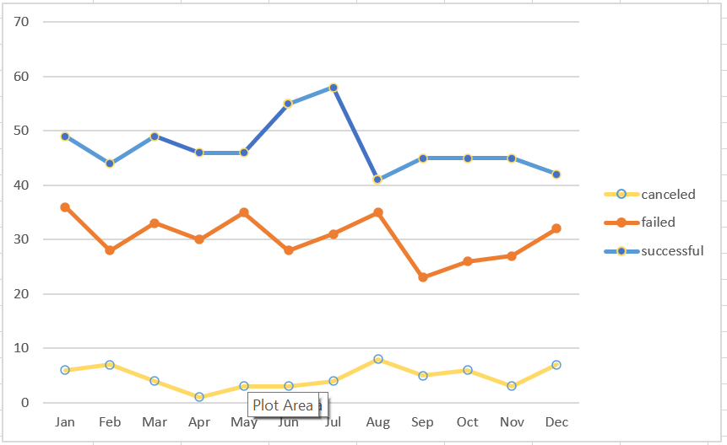

* What are some limitations of this dataset?
* There dataset is not large enough for all categories and subcategories, so some of the results are not statistically relevant given the small sample size. We need to figure out how statistically significant these results are.
* We need to analyze a variety of crowdsourcing companies to draw more significant insights.
* What are some other possible tables and/or graphs that we could create, and what additional value would they provide?
* It would be interesting to analyze the projects by the duration of conversion using the date created conversion and date ended conversion. Maybe there is a trend to see what separates the duration of successful and unsuccessful projects.
* If we could analyze the data by states, we could see trends in which states have CrowdSourcing with the highest rates of success and which ones have the lowest rate of success.
* We need more information on the “successful” state. Just because a campaign reached its goal and delivered the products and services can we take it a step further and find out how many are successful in the long run. More importantly how many of the “successful” campaigns became profitable and established companies.